TITLE: AI Smart Queue Management
ABSTRACT:
The AI-Powered Smart Queue & Crowd Intelligence System is an intelligent crowd management solution designed to reduce waiting time, overcrowding, and inefficiency in public service areas such as hospitals, banks, railway stations, and government offices. The system utilizes Artificial Intelligence and Computer Vision techniques to analyze real-time video feeds from cameras and detect the number of people in queues.
Using OpenCV-based human detection, the system continuously monitors crowd density and calculates the number of people present in the queue. Based on this analysis, it estimates the waiting time, determines queue status (Normal, Busy, or Overcrowded), and provides smart recommendations such as directing users to alternative counters.
Additionally, the system includes a voice-based alert mechanism that announces queue updates, waiting time, and recommendations to improve user experience and accessibility. This reduces confusion, improves service efficiency, and helps in better crowd control without requiring additional infrastructure.
Overall, this project demonstrates how Artificial Intelligence can be applied in real-world scenarios to automate queue management, enhance public service efficiency, and improve user convenience through smart decision-making systems.

PROBLEM STATEMENT:
In many public service environments such as hospitals, banks, railway stations, and government offices, managing queues and crowd flow efficiently is a major challenge. During peak hours, limited counters and increasing crowd size lead to long waiting times, overcrowding, and lack of proper queue monitoring. Traditional manual queue systems are inefficient and cannot provide real-time updates or predict waiting times accurately.
Due to the absence of smart monitoring systems, people often face confusion about their position in the queue, estimated waiting time, and availability of alternative counters. This results in frustration, time wastage, and poor service management.
Therefore, there is a need for an intelligent system that can automatically detect crowd density, manage queues in real time, estimate waiting time, and provide smart recommendations to improve overall service efficiency and user experience.

OBJECTIVES:
- To reduce waiting time in queues.
- To monitor crowd using AI and Computer Vision.
- To count people in real time.
- To estimate waiting time automatically.
- To provide smart queue status and recommendations.
- To improve crowd management and user experience.

TECHNOLOGIES USED:
- Python
- OpenCV (Computer Vision)
- HOG + SVM (People Detection)
- pyttsx3 (Voice Output)
- NumPy

WORKING EXPLANATION:
The system uses a webcam to capture real-time video of a queue area. Each frame is processed using OpenCV and a HOG-based human detection model to identify and count the number of people in the queue. Based on the count, the system calculates the estimated waiting time and determines the queue status such as Normal, Busy, or Overcrowded.
If the crowd increases beyond a limit, the system provides smart recommendations like suggesting alternative counters. Additionally, a voice module announces the current queue status, waiting time, and instructions at regular intervals to improve user awareness. The processed video is displayed in real time and can also be saved as output for analysis.

CODE SNIPPET:
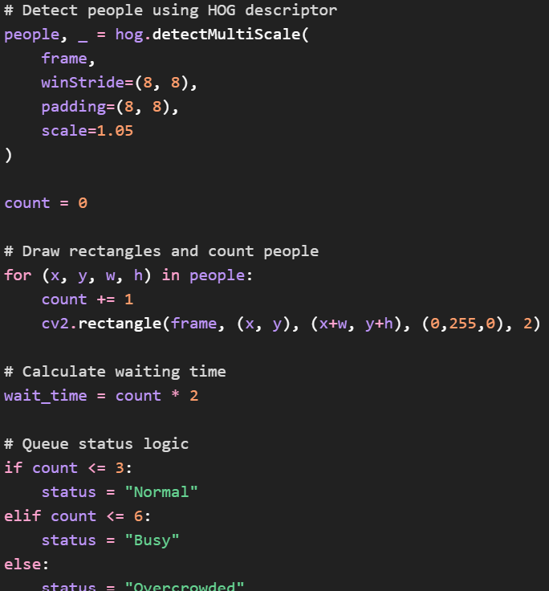

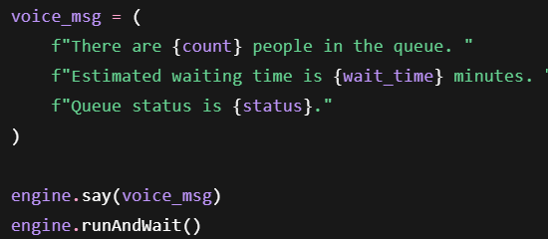

OUTPUT:
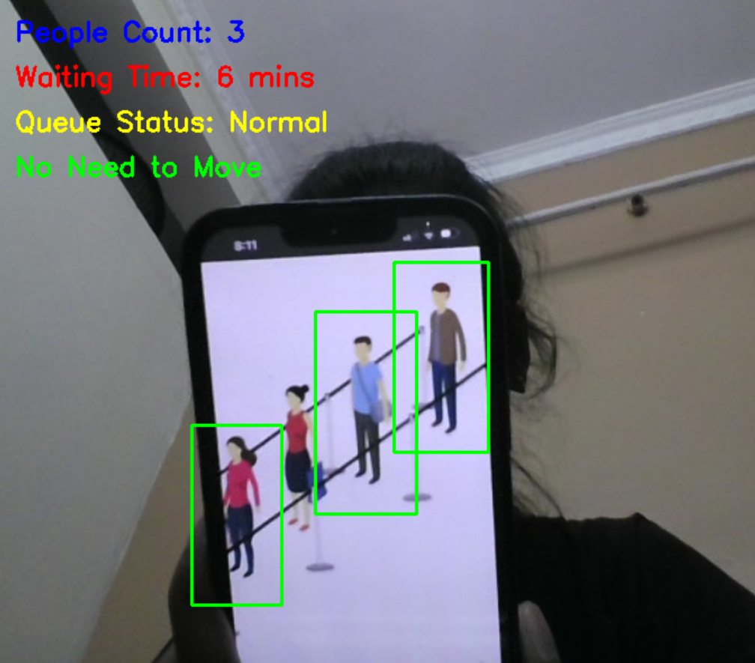

OUTPUT EXPLANATION:
The output of the AI-Powered Smart Queue & Crowd Intelligence System is displayed in real time through a webcam window. The system detects people in the queue using computer vision and draws bounding boxes around each detected person. It continuously counts the number of people present and updates the queue status dynamically.
Based on the detected count, the system displays:
- Number of people in the queue
- Estimated waiting time
- Queue status (Normal, Busy, or Overcrowded)
- Smart recommendation (e.g., move to next counter or wait)
In addition to visual output, the system also provides voice announcements that inform users about the current queue status and waiting time at regular intervals. This helps users understand queue conditions without constantly looking at the screen.

CONCLUSION:
The AI-Powered Smart Queue & Crowd Intelligence System successfully demonstrates an efficient way of managing queues using Artificial Intelligence and Computer Vision. The system is capable of detecting and counting people in real time, estimating waiting time, and providing queue status updates such as Normal, Busy, or Overcrowded.
It also improves user experience by giving smart recommendations and voice-based announcements, which help reduce confusion and waiting discomfort. This project shows how AI can be effectively applied in real-world environments to improve crowd management, reduce waiting time, and enhance overall service efficiency in public places.

